What Is

Anki

And Why You Should Use It

For Vocabulary Learning

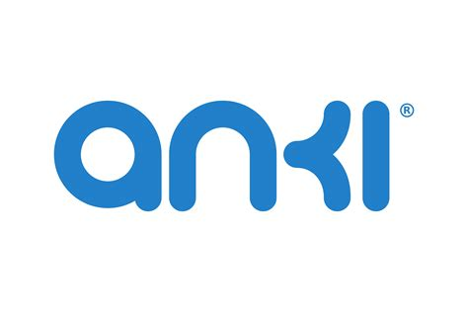
  - Automatic and digital spaced repetition algorithm in a free & open-source app to help you retain more words in your target language!


Shef broski
15.09.2026, v1.0
Table of contents
1. Actively learning vocabulary 1
2. What is Anki and how it works 2
2.1. What is a flashcard 2
2.2. Spaced repetition system and the algorithm 2
2.3. Why Anki 4
3. Considerations for beginners 4
3.1. Common misconceptions & pitfalls 5
3.2. Habits for success 5
4. Anatomy of a flashcard 6
Bibliography 8
Anki official links 8
References and further reading 8

1. Actively learning vocabulary
Every casual and serious language learner eventually realizes that the bottleneck in progressing through a new language is the vocabulary. After some point, they would reach more than enough grammar, pronunciation, and reading/listening levels. Comprehension is what distinguishes a B1 from a C1. They may hear the word and even tell in what grammatical case or position it is in a sentence, but they struggle to find its meaning. And of course, when trying to say or write something themselves, the only things in memory are the most basic everyday words.
This doubly applies to absolute beginners as well; it is just that they are usually overwhelmed with all the grammar, pronunciation, and the script sometimes. However, if their vocabulary is rich enough for their level, then they should be more than comfortable to make out the key words in a sentence and figure out the general meaning through context. Therefore, the boring vocabulary grinding is (unfortunately) a very efficient core part of learning a language.
However, it is not the only way. Some people choose to go with the less efficient but more fun way to pick up vocabulary: Immersion, a.k.a. passive learning. This process takes significantly more time (years) and requires hours spent consuming media and literature in the target language. Which can be really entertaining and not feel like language learning at all once you reach the comfortable B2 range.
This booklet will try to convince you to start doing the boring efficient way. There is no point debating which one is better, as the first best way is the way that gets you to learn, and the second best way is to do a mix of both. Besides you may find the “boring” way actually enjoyable or vice versa.
Before getting to Anki, just to make it clear what is meant by “Active vocabulary learning”: It is, basically, sitting down and studying (new) words for the sake of increasing your known words bank. So it is not a system to find new words, or a new way to learn the entire language as a whole. This is just a complementary part to your learning, which should be accompanied with a variety of methods and activities. Over time, it is quite natural to drop or adopt new methods as well. Everyone is different; there can’t be a single best way, so experiment with everything!

2. What is Anki and how it works
Anki is a free & open-source software, built on core cognitive science concepts like “Active recall” and “Spaced Repetition”. It is used by students and serious learners from many fields including language learning. Since so much of language learning is brute memorization, Anki—and various other so-called flashcard apps—have gained popularity in that community. Indeed, there are many anki clones, but I recommend sticking with Anki for numerous reasons.
Technically, you may not even need a digital app for flashcards since the general idea is quite simple, and the algorithm is intuitive. Before we get into the details, let’s first explain the terms we are working with.

2.1. What is a flashcard
A flashcard is a card designed for learning with information on both sides. It relies on active recall: one side displays a prompt/question, and the other side displays the answer or target information that should be “actively recalled” before flipping. Basically, a trigger for the right information. For language learning, it can be a word in target language on one side, and the definition/translation on the other. In this case, it works both ways, i.e., finding the word in target language from the definition.
The card can be a physical card, or even better a digital card. The benefits of digital is creating a database (hundreds or thousands) of all the cards; making searching, editing, and overall management easy.
More on flashcards in 4. Anatomy of a flashcard.

2.2. Spaced repetition system and the algorithm
A Spaced Repetition System (SRS) is a learning technique that adjusts the time intervals (space) between how often your repeat some piece of information depending on how easily you can remember it. It directly targets how human short-term memory decays over time.
When you learn a new word, your brain begins to forget it rather quickly since it is not in the long term memory—psychologically known as the forgetting curve (Figure 1). You can review the word too soon and waste time since you are testing memory that is still solid, or you can review it too late and risk completely forgetting the word and having to relearn it from scratch.
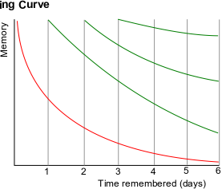
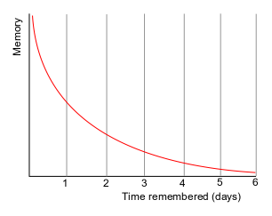
Figure 1: Forgetting Curve
(Icez at English Wikipedia)
Figure 2: Forgetting Curve with SRS
(Icez at English Wikipedia)

The algorithm works by striking at the sweet spot (Figure 2): right before you are about to forget. And there is nothing complicated about the algorithm either, you could recreate it with physical cards, even implement the algorithm once you understand it (cumbersome, not recommended).
How it works:
- Initial exposure: You see a new word today and are presented with difficulty options every time (Again, Hard, Good, Easy).
- Short intervals for hard cards: If you struggle to recall some cards, the system will bring up those cards more often (e.g., in 10 minutes, then again tomorrow, ...).
- Expanding long intervals for easy cards: Each time you easily recall the word, the algorithm multiplies the time until the next review if you keep getting it right (e.g., 1 day → 3 days → 10 days → 1 month → 6 months →...).
The algorithm adapts to your memory quickly and accurately.
Anki simply hosts your cards and applies this algorithm to it. It will organize everything, and have all the cards for review today, everyday, ready. All you need to do is complete your daily reviews and occasionally add the new words you learn.
Side Note on the algorithm: Anki’s new (version 23.10+) default algorithm called FSRS (Free Spaced Repetition Scheduler) is an improved scheduling method of the legacy SM-2 algorithm explained above. Make sure it is enabled if you decide to try Anki out, as it could produce the same retention rates for 20-30% fewer reviews.

2.3. Why Anki
By now, it is (hopefully) clear why a digital app is the most practical way to manage flashcards. You avoid maintaining an ever-growing box of physical cards or manually sorting them for daily reviews—the software handles all scheduling automatically.
While many flashcard apps exist, Anki remains the preferred choice for most thanks to several points:
- Full Ownership & Privacy: You have total control over your data. Cards can be stored entirely locally on your machine without mandatory cloud tracking or proprietary lock-in. (read more on enshittification)
- Seamless Cross-Platform Sync: With the optional, built-in free AnkiWeb cloud service, your decks—collections of cards grouped by subject—synchronize effortlessly across all your devices. You can add cards on your desktop and review them on your phone anywhere.
- Complete Customization: Anki avoids restrictive "hand-holding." You can build custom card templates, integrate media (audio, images, LaTeX), and alter review settings to match your specific learning pace. (You don’t need to bother with everything here for starters.)
- Free & Open-Source Ecosystem: Anki is available free of charge on Windows, macOS, Linux, Web, and Android (AnkiDroid). The iOS app (AnkiMobile) requires a one-time purchase to support development.
- Massive Community & Ecosystem: A vast global community creates and shares thousands of free pre-made decks across dozens of languages. Additionally, users can benefit from an extensive library of add-ons that extend the app’s functionality.

3. Considerations for beginners
If you are used to staring at long vocabulary lists or endlessly writing words out in a notebook, Anki is somewhat different. Instead, it is just a quick daily routine:
- You open the app.
- Review a stack of “review” words that are right on the verge of slipping your mind (some from the hard ones yesterday, some from the medium ones this week, and some from the easy ones last month).
- Rate how well you remembered each one (Again, Hard, Good, or Easy).
- Learn a small batch of new words (10 to 15).
- Close the app and you're done.
In 10 or 15 minutes, you finish your vocabulary study for the day. The algorithm handles all the scheduling behind the scenes, so you never have to waste time planning what to review next. If you are building your own deck, an extra process is to add the new words you learn as you learn them, or save them somewhere then add them cleanly every now and then.
Transitioning to a SRS for vocabulary learning requires a mindset shift. Here are some practical points on discipline, sustainability, and avoiding early burnout.

3.1. Common misconceptions & pitfalls
- Anki Is Not a Full Curriculum: Anki acts as a vocabulary accelerator, not a standalone course. It builds the raw memory bank, but active listening, reading, grammar practice, and speaking are needed to turn those words into real fluency.
- Over-Studying & Bloated Decks: Adding 50 new cards a day quickly creates unsustainable review waves. Limiting it to 10–20 new words a day keeps the daily routine to a focused 10–15 minutes.
- Fear of the Backlog: Missing a few days will not ruin your deck (and progress). The algorithm simply pauses until you return; you can clear the queue at your own pace without resetting your cards.
- Over-Categorizing with Sub-Decks: Beginners often create separate sub-decks for every topic (e.g., "Food", "Travel", "Verbs"). It is far more efficient to use one main deck per language—and organize specific topics using tags. I recommend just doing everything plainly until you build the habit and understand how everything works to understand what would work for you. After all, KISS is king (Keep It Simple Stupid).

3.2. Habits for success
- Card creation is studying: You can grind pre-made decks by other people, but creating your own personal deck with your words that have learned before is already studying before the reviewing.
- Daily consistency beats marathons: Doing 10 minutes every day (anywhere/anytime, e.g., while waiting for the bus) is vastly superior to a 2-hour marathon once a week. That is the whole point of SRS.
- Be ruthless with bad cards: If a card is confusing, poorly formatted, or constantly trips you up, suspend or delete it. Re-write the prompt or throw it out so single cards don't drag down your momentum. The more you use Anki, the better you get at card creation. The point is not to have the most beautiful looking cards and deck.

4. Anatomy of a flashcard
A good experience of reviewing your cards boils down to the quality of the cards you make. Bad cards create friction and slow down the recall.
The golden rules:
- Minimum information principle: Test only one specific word or concept per card. Do not clutter cards with full conjugation tables or multiple definitions.
- Always use context: Include a short, natural example sentence. Isolated words don’t get connected naturally in the brain and would not come to mind when needed.
- Keep prompts clear: The front of the card should immediately trigger a single, distinct answer so you never have to guess what you are testing yourself on.
Card creation example:
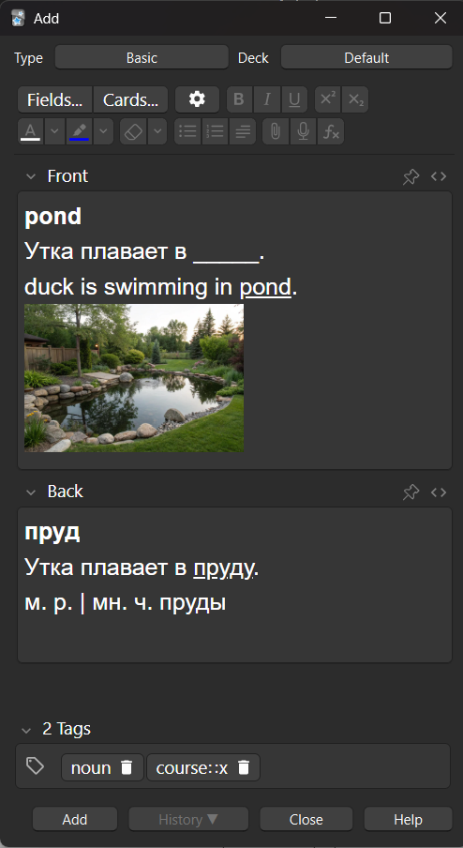

Russian
Optional: tags for deck organisation
Optional: Additional information (Grammar, gender, or plural form)
Blank filled
Answer in the back
Sentence(s) for context with prompt word left blank and its translation
Optional: Image
(really good for nouns)
Prompt in the front (recall the russian word for “pond”)

Bibliography

Anki official links
- Anki Homepage — Official site to download and other information https://apps.ankiweb.net/
- Anki Manual — Official documentation for setup, settings, and customization https://docs.ankiweb.net/
- Anki Shared Decks — Community-created vocabulary lists https://ankiweb.net/shared/decks?sort=title
- AnkiWeb — Create a free account and sync your decks online https://ankiweb.net/about

References and further reading
[1] Flashcards World — More tips on creating flashcards https://flashcards.world/wiki/learn-a-new-language-with-flashcards/
[2] Wikipedia — Ebbinghaus forgetting curve https://en.wikipedia.org/wiki/Forgetting_curve
[3] Wikipedia — Spaced Repetition https://en.wikipedia.org/wiki/Spaced_repetition
[4] Medankigen — FSRS in Anki: What It Is, How It Works, and How to Set It Up (2026) https://medankigen.com/blog/fsrs-anki

This guide is free and available on my GitHub at [https://github.com/shef-broski/intro-to-anki] under CC BY-NC 4.0. Feel free to share and adapt with attribution.
Found an error or want to reach out?
Discord: @shef_broski

free: as in freedom (libre), not freemium; Anki for iOS requires a one-time purchase
Wikipedia: [https://en.wikipedia.org/wiki/Free_and_open-source_software]
Wikipedia: [https://en.wikipedia.org/wiki/Forgetting_curve]
Wikipedia: [https://en.wikipedia.org/wiki/Spaced_repetition]
Anki Manual: [https://docs.ankiweb.net/]
Medankigen FSRS in Anki: [https://medankigen.com/blog/fsrs-anki]
AnkiWeb: [https://ankiweb.net/about]
Anki Shared Decks Directory: [https://ankiweb.net/shared/decks?sort=title]
Flashcard World: [https://flashcards.world/wiki/learn-a-new-language-with-flashcards/]

